Week 1  Start practising: 8.9.25  Test: 15.9.25 | Week 2  Start practising: 15.9.25  Test: 22.9.25 | Week 3  Start practising: 22.9.25  Test: 29.9.25 | Week 4  Start practising: 29.9.25  Test: 6.10.25 | Week 5  Start practising: 6.10.25  Test: 13.10.25 | Week 6  Start practising: 13.10.25  Test: 20.10.25
Spelling Rule:  -tion  (shun sound)  Used if root word ends in t or te.  E.g. hesitate = hesitation. | Spelling Rule:  -sion  (shun sound)  Used if root word ends in d or se.  E.g. extend = extension. | Spelling Rule:  -sure  (zhuh sound)      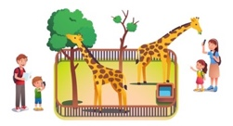 | Spelling Rule:  -ture  (chuh sound)    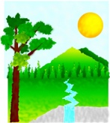  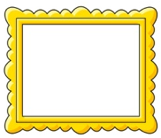 | Spelling Rule:  Revise -tion and -sion  We will revise all week 1 and 2 words in school. | Spelling Rule:  Revise -sure and -ture  We will revise all week 3 and 4 words in school.
invention | tension | measure | creature | infection | treasure
injection | mansion | treasure | furniture | correction | pleasure
action | extension | pleasure | picture | hesitation | enclosure
infection | expansion | enclosure | nature | expansion | creature
correction | comprehension | exposure | adventure | comprehension | furniture
hesitation | pension | closure | denture | pension | nature
Unruly Spellings:  accident, actual | Unruly Spellings:  address, answer | Unruly Spellings:  appear, arrive | Unruly Spellings:  believe, bicycle | Unruly Spellings:  breath, breathe | Unruly Spellings:  Revise previous unruly spellings.

